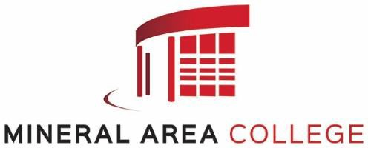

THE COLLEGE
The Paramedic Technology Certificate is an
extended four-semester program consisting of 45 total program credit hours.
Graduates of the program are prepared to perform advanced life support to the acutely ill and injured. They are skilled in-patient
assessment and recognition of diagnostic signs and symptoms of illness and injury. Through an advanced evidence-based curriculum, students are trained to evaluate patients and deliver
treatment rapidly and efficiently, thereby
reducing morbidity and increasing mortality. Training consists of classroom instruction,
simulation and laboratory practicum, field internship experience, and hospital clinical rotation.
Upon successful completion of the program, the graduate is eligible to apply to take the National Registry Exam. Satisfactory achievement on the examination will qualify graduates for licensure as a Paramedic.

THE PROGRAM
Paramedic Technology Certificate of Proficiency prepares students for positions as emergency medical technicians-paramedics. Paramedics are skilled in-patient assessment and recognition of diagnostic signs and symptoms of major injuries and illnesses. They learn to use ambulances, rescue vehicles, and hospital emergency room equipment to provide high- level emergency medical care and stabilize emergency patients. Paramedics also are trained to provide advanced life support including fluid and drug therapy, as well as the performance of some essential emergency surgical techniques under the written or oral orders of licensed physicians.
Students should have maturity in dealing with others. They should have good manual dexterity and physical coordination for carrying, lifting, extricating, climbing, hoisting, etc. In addition, they should be able to give as well as receive written and oral directions and instructions. Good vision and visual color discrimination are

PARAMEDIC TECHNOLOGY CERTIFICATE PROGRAM

FALL 2026

necessary for the examination of patients for determining diagnostic signs requiring immediate treatment.

PROGRAM PREREQUISITES
- Graduate of an approved high school or the equivalent as determined by appropriate
accrediting agencies (i.e. GED and HiSET).
- Basic computer knowledge as evidenced by a high school or college computer course.
- At least 18 years of age by program start date.
- Valid EMT licensure in good standing or expect to obtain an EMT license by program start date.
- Accuplacer Next Generation academic testing with the following minimums scores:

Writing: 250
Math (QAS): 250
Reading: 250
- Successful general application and acceptance to Mineral Area College.
- Completion of Paramedic Anatomy & Physiology OR Human Anatomy & Physiology

APPLICATION PROCESS
The application deadline for the paramedic program that begins the Fall 2026 term is March 16, 2026.
Ensure the following documentation is on file by the deadline:
Paramedic application Academic test scores
Official copies of dual credit and transfer transcripts Reference Contact Information Form
Personal Interview (to be scheduled)
After being accepted into the program you will be contacted by the Office of EMS Education Programs and a Pre-Course Requirements Packet will be mailed to you. Students will also be required to successfully pass a background check and drug screening. All of this information is covered in detail in the packet.
All applicants accepted into the program are considered on conditional status pending:
Required identification documentation Drug screening and background check Immunization requirements
BLS for Healthcare Providers CPR Certification

Successful completion of the program, however, does not guarantee eligibility to take the licensure exam or to become licensed.

Applications for the paramedic program in accordance with the requirements in this
publication must be submitted by
March 16, 2026
to the Office of EMS Education.

PROGRAM CURRICULUM

Prerequisites

Credits

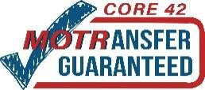
Mineral Area College programs meet DHE Core 42 guidelines. Courses are MOTRansfer guaranteed as indicated.

The Certificate in Paramedic Technology program is accredited by the Missouri Bureau of EMS. The Mineral Area College paramedic program is accredited by the
Commission on Accreditation of Allied Health Education Programs upon the recommendation of the Committee on Accreditation (CAAHEP) of Educational Programs for
Emergency Medical Services Professions (CoAEMSP).

Commission on Accreditation of Allied Health Ed. Programs 25400 U.S. Highway 19 North, Suite 158
Clearwater, FL 33763
(727) 210-2350
www.caahep.org
Committee on Accreditation of Educational Programs for the Emergency Medical Services Professions
8301 Lakeview Parkway, Suite 111-312
Rowlett, TX 75088
(214) 703-8445
www.coaemsp.org

Mineral Area College does not discriminate on the basis of race, color, national origin, gender identity, disability, age, religion, creed, sexual orientation, genetic and family medical history, or marital or parental status. For more information, contact the Human Resources Director, Title VI and VII, Title IX, Section 504, and ADA Coordinator at
(573) 518-2378

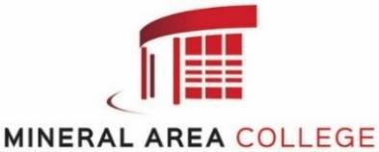
Mineral Area College is fully accredited
by the Missouri Department of Education and the:

Higher Learning Commission 230 N. LaSalle Street, Suite 7-500
Chicago, Illinois 60604
Phone: (800) 621-7440
BIO 2540 Human Anatomy & Physiology OR 5
PAR 2100 Paramedic Anatomy & Physiology 4
1st Semester (Fall)
PAR 2013 Principles of Paramedic Technology I 6
PAR 2083 Paramedic Pharmacology 6
PAR 2213 Paramedic Clinical I 3
GUI 1010 First Year Seminar 1
Total Sem Cr Hrs 16
2nd Semester (Spring)
PAR 2023 Principles of Paramedic Technology II 6
PAR 2123 Paramedic Cardiology 6
PAR 2223 Paramedic Clinical II 4
Total Sem Cr Hrs 16
3rd Semester (Summer)
PAR 2043 Principles of Paramedic Technology III 5
PAR 2263 Paramedic Clinical III 3
Total Sem Cr Hrs 8
4th Semester (Fall)
PAR 2353 Paramedic Field Internship Seminar 1
PAR 2373 Paramedic Field Internship Capstone 4
TSA 0000 Technical Skills Assessment 0
Total Sem Cr Hrs 5
TOTAL PROGRAM CREDIT HOURS: 45

